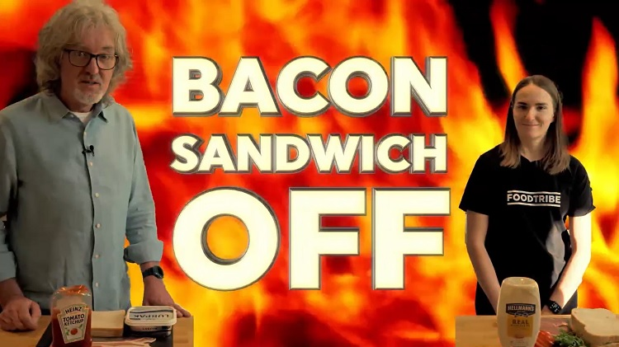
1. What is the question that is impossible to answer according to James May?

2. Apparently Lucy Brown is posh and ‘Bourgeois’. What does it mean to be bourgeois?

3. List all of the items Lucy has for her Sarnie.

4. List all of the items James has for his butty

5. What will they use for topping the sandwiches?

6. Which of them is making the bacon sandwich of the people?

7. Bacon frying duties fall to Lucy while James does the buttering. What has Lucy done that could sabotage James’ bacon?

8. Payback is a bitch. What does James do to sabotage Lucy?

9. What does James want to buy because it is ‘Un Gadget’?

10. What tip from Lucy is James going to apply to his sandwich?

A Mr Josh Production

11. Lucy implies that James is a picky eater. True or false?

12. James mentions ‘shenanigans’ and ‘jiggery pokery’. What do these two terms mean?

13. What does Lucy do that makes James wince in pain?

14. Lucy does not sit down for afternoon tea with a cucumber sandwich. What does she have with her afternoon tea?

15. What is causing James’ gut to rumble?

16. What important question does James have for Tom?

17. What is like evidence at a crime scene?

18. Describe the look of Lucy’s sandwich, and of James’ sandwich.

19. Having had a chomp on their own finished product, what do they each say about their own sandwich?

20. The votes are in, who won?

A Mr Josh Production

