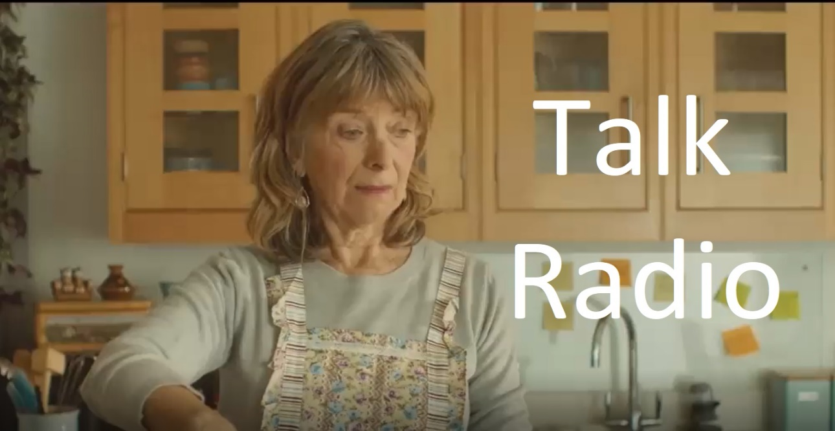
1. Describe the opening scene up to the point that Barry walks into the room.
Pauline is in a kitchen preparing dinner while listening to 105.5 Talk Radio.
2. Barry says that he is going to ‘tinker’ with the lawnmower, meaning that he will try and repair it. But what is another meaning for the word ‘tinker’?
A tinker can be a mischievous child or a person that travels the country offering to do odd jobs. https://tinyurl.com/upad4kd8
3. Pauline turns up the radio and we catch the final comment from a caller. What does the caller say?
. . . and we pulled it out and it’s healed nicely!” 1.09
4. The next caller comes on the line. Why does Pauline suddenly pause what she is doing?
Pauline pauses what she is doing because she believes her husband is on the radio. 1.41
5. What is the name of the family dog?
Dog? No idea, but the cat is called Jorge 2.01
6. The caller begins to talk about his problem. What does he say that shocks the host?
The caller says that his wife is a bit of a cunt. 2.26
7. The host tells the caller to “keep a lid on it”. What does this mean?
To keep a lid on something means to try and control it.
8. What three things does the caller say he and his wife do not do?
The caller says that they do not argue, talk, or have sex. 2.44
9. How does the caller describe his wife’s face?
The caller says that his wife’s face is annoying and weird looking. 3.00
10. Fill in the blanks.
Don’t even get me started on my son. I don’t know what hope he’s got in life. Barely even got his GCSEs, such a thicko. Can’t even say he can rely on his looks. When he was dropped as a baby it must have been on his face, I love, him of course, but he’s a circus freak!
11. Having finished the character assassination of his son, what is the caller’s next target?
The caller moves onto speaking about how bad his wife’s cooking is. 3.33
12. The camera zooms in to a photo on the fridge door. Who is the woman, and what are the caller’s feelings about this person?
The woman is Pauline’s mother, who the caller hated and says it was the happiest day of his life when she died. 3.45
13. The caller says that he had to give up on his dreams. Why did he do this?
He gave up on his dreams because family life got in the way. 3.55
14. During his fleeting moments of happiness in the shed, what does the caller find himself thinking about?
The caller finds himself wondering if he has a sexual attraction to the cat. 4.12
15. The radio host has an opinion about the caller. What is his opinion?
The host’s opinion is that the caller badly needs professional help. 4.19
16. Pauline appears to be on the verge of tears. But what does the caller say that begins to raise a smile from Pauline?
Pauline raises a smile when the caller begins to talk about how they used to be together when they were young. 4.31
17. What did the caller do with his wife for hours and hours and hours and hours. . .?
The caller and his wife used to make love for hours and hours. 4.42
18. The caller thinks that he has the answer to why his marriage went wrong. What is it?
The truth is that he stopped making the effort to keep his marriage happy. 5.00
19. If he could go back in time, what would the caller do?
If the caller could go back in time, he would make his family the centre of his world and fill them with love. 5.15
20. Barry walks into the kitchen and sees his obviously distraught wife. What does he ask her?
Barry asks his distraught wife if she needs any help with dinner. 6.00
21. What does Barry say that flips Pauline from sadness to rage?
Barry says, “I hope you put some salt in that”. 6.24
22. Barry turns his back on Pauline. What is he looking for, and why is this his final mistake?
Barry turns his back to look for the cat. It’s his final mistake because Pauline kills him with a frying pan. 6.27
23. What is Pauline saying while venting her frustrations?
Pauline is saying “I use the correct amount of seasoning in every meal!” 6.39
24. What does Pauline use to steady her nerves after ‘dealing’ with her husband?
Pauline starts drinking from a large glass of red wine to steady her nerves. 7.09
25. Sat on a kitchen stool does Pauline look,
A. Horrified B. Terrified C. Satisfied D. Vilified E. Some other word ending in fied?
26. Who has been inundated with worried texts and tweets while the music has been playing?
The producer of the radio show has been inundated with calls about Jorge. 7.41
27. What happens to change Pauline’s calm expression to one of subdued horror?
The person Pauline thought was her husband comes back on the line to speak again. 8.00
28. What is the final thing that Pauline says?
Oh Bollocks! 8.07

