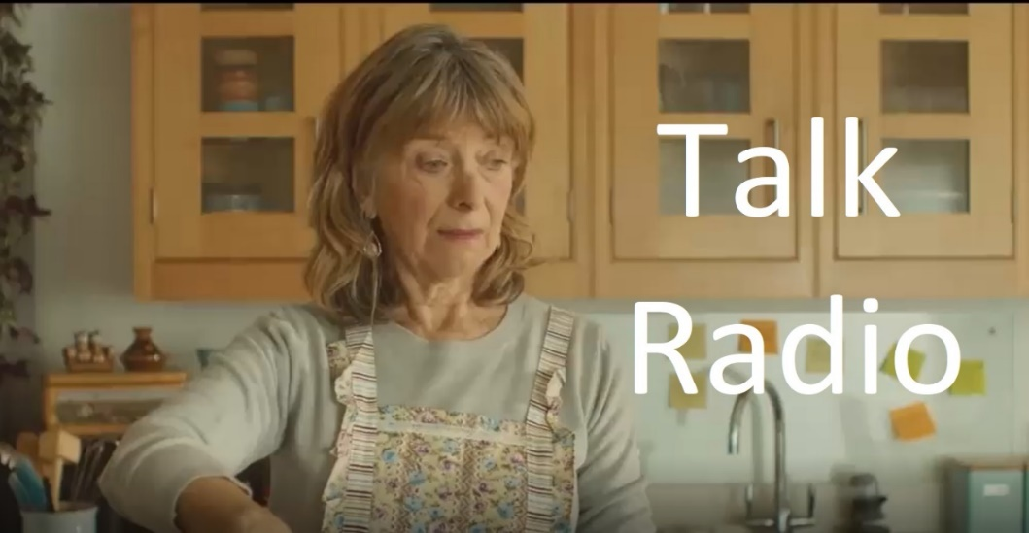
1. Describe the opening scene up to the point that Barry walks into the room.

2. Barry says that he is going to ‘tinker’ with the lawnmower, meaning that he will try and repair it. But what is another meaning for the word ‘tinker’?

3. Pauline turns up the radio and we catch the final comment from a caller. What does the caller say?

4. The next caller comes on the line. Why does Pauline suddenly pause what she is doing?

5. What is the name of the family dog?

6. The caller begins to talk about his problem. What does he say that shocks the host?

7. The host tells the caller to “keep a lid on it”. What does this mean?

8. What three things does the caller say he and his wife do not do?

9. How does the caller describe his wife’s face?

A Mr Josh production

10. Fill in the blanks.
Don’t even get me . . . . . . . . . . . . . . I don’t know what hope he’s got in life. Barely even got . . . . . . . . . . . . . . . . . . . . . . Can’t even say he can rely on his looks. When he . . . . . . . . . . . . . . . . . . . . . . . . . . . . . . . been on his face, I love, him of course, but . . . . . . . . . . . . . . .!
11. Having finished the character assassination of his son, what is the caller’s next target?

12. The camera zooms in to a photo on the fridge door. Who is the woman, and what are the caller’s feelings about this person?

13. The caller says that he had to give up on his dreams. Why did he do this?

14. During his fleeting moments of happiness in the shed, what does the caller find himself thinking about?

15. The radio host has an opinion about the caller. What is his opinion?

16. Pauline appears to be on the verge of tears. But what does the caller say that begins to raise a smile from Pauline?

17. What did the caller do with his wife for hours and hours and hours and hours. . .?

18. The caller thinks that he has the answer to why his marriage went wrong. What is it?

19. If he could go back in time, what would the caller do?

20. Barry walks into the kitchen and sees his obviously distraught wife. What does he ask her?

A Mr Josh production

21. What does Barry say that flips Pauline from sadness to rage?

22. Barry turns his back on Pauline. What is he looking for, and why is this his final mistake?

23. What is Pauline saying while venting her frustrations?

24. What does Pauline use to steady her nerves after ‘dealing’ with her husband?

25. Sat on a kitchen stool does Pauline look,
A. Horrified B. Terrified C. Satisfied D. Vilified E. Some other word ending in fied?
26. Who has been inundated with worried texts and tweets while the music has been playing?

27. What happens to change Pauline’s calm expression to one of subdued horror?

28. What is the final thing that Pauline says?

A Mr Josh production

